Software Architecture Specification Report – Rough Draft

Team LER: Amazon Alexa O&M Skill

Eric Schulze, Ryan Gosling, Larome Dickerson

Software Architecture Specification Report – Rough Draft

Team LER: Amazon Alexa O&M Skill

Eric Schulze, Ryan Gosling, Larome Dickerson

2017

**Table of Contents**

1. Overview …………………………………………………………………………………………………2

2. Subsystem Decomposition …………………………………………………………2

3. Hardware/Software Mapping ……………………………………………………2

4. Persistent Data Management …………………………………………………3

5. Access Control and Security ………………………………………………3

6. Global Software Control …………………………………………………………4

7. Boundary Conditions ……………………………………………………………………4

**1. Overview**

The American Printing House for the Blind (APH) is the world’s largest company devoted to manufacturing, researching, and developing products for people who are blind or visually impaired. APH designs and manufactures textbooks and magazines in braille, large print, and digital formats, as well as other educational, recreational, and daily living products, one of which we have been tasked to develop. APH has requested our services to develop a skill for Amazon’s Alexa voice interface platform.

This skill will consist of a trivia game in which the subject of Orientation and mobility (O&M) will be the focus. The O&M trivia game will be used in concurrence with the training, and education provided to the visually impaired through all stages of life. Blindness or visual impairment can happen to an individual through different stages of their life, from birth to old age, and learning through engagement will solidify the skills they will need to survive in a visual based world, which this Alexa skill will provide.

1a. Glossary

APH: American Print House for the Blind, our project sponsor

O&M: Orientation and Mobility, a subject of instructional lessons for the visually impaired that APH works with

Skill: A capability of Alexa, the Amazon cloud based service that handles speech recognition, machine learning, and natural language understanding, that defines how you can interact with Alexa.

Interaction Model: The Voice User Interface (VUI) of the skill, it defines what functionalities or behaviors the skill is able to handle

Hosted Service: The programming logic of the skill, hosted by Amazon Lambda Services, that responds to a user’s requests and phrases

Utterance: A phrase from the user that the skill can understand and map to an intent

Intent: A representation of functions that the skill is capable of performing. Multiple utterances can map to one intent that then gets passed on to the Hosted Service.

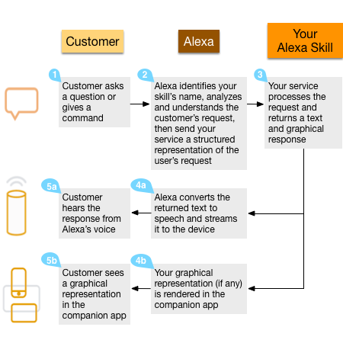1b. System Overview

The Alexa skill will consist of two individual parts working in tandem with each other, the Interaction Model and the Hosted Service. The Interaction Model is a voice user interface (VUI) for the Alexa skill. The Interaction Model is to the skill, what a graphical user interface is to a mobile application; it defines how a user is able to interact with our skill. This Interaction model includes the intents and utterances that a user can use. The intents and utterances trigger responses based on the second part of the skill, the Hosted Service. The hosted service is the brains behind how Alexa handles responses and phrases from the user. The hosted service takes as input intents, deciphered from the user utterance by the VUI, and outputs response phrases.

1c. References

Amazon Alexa Skills Kit (<https://developer.amazon.com/alexa-skills-kit>)

Alexa Skills Documentation (<https://developer.amazon.com/public/solutions/alexa/alexa-skills-kit/overviews/understanding-custom-skills>)

Codecademy – Build Alexa Skills (<https://www.codecademy.com/learn/learn-alexa>)

**2. Subsystem Decomposition**

**3. Hardware/Software Mapping**

**4. Persistent Data Management**

**5. Access Control and Security**

5a. Users

Users of the APH O&M skill will only have access to the skill through an Alexa enables device or application. All of these devices or applications are linked to a user’s Amazon account, and as such, all authentication is handled by Amazon’s security services. When a user is authenticated to use a device, the device has a unique id that is sent to the Alexa server with every request. The APH O&M will use this device id to track games and settings.

Users will be able to use all VUI features of the Interaction Model. There will not be any distinction between different kinds of users.

5b. APH System Admin

A System Admin from APH will have access to the Interaction Model, the Hosted Service, and the DynamoDB through the Amazon AWS portal. This will allow for updates and revisions of any of the system components. These services will be passed on to APH at the conclusion of the project.

**6. Global Software Control**

6a. Stage 1: Outside APH O&M Skill

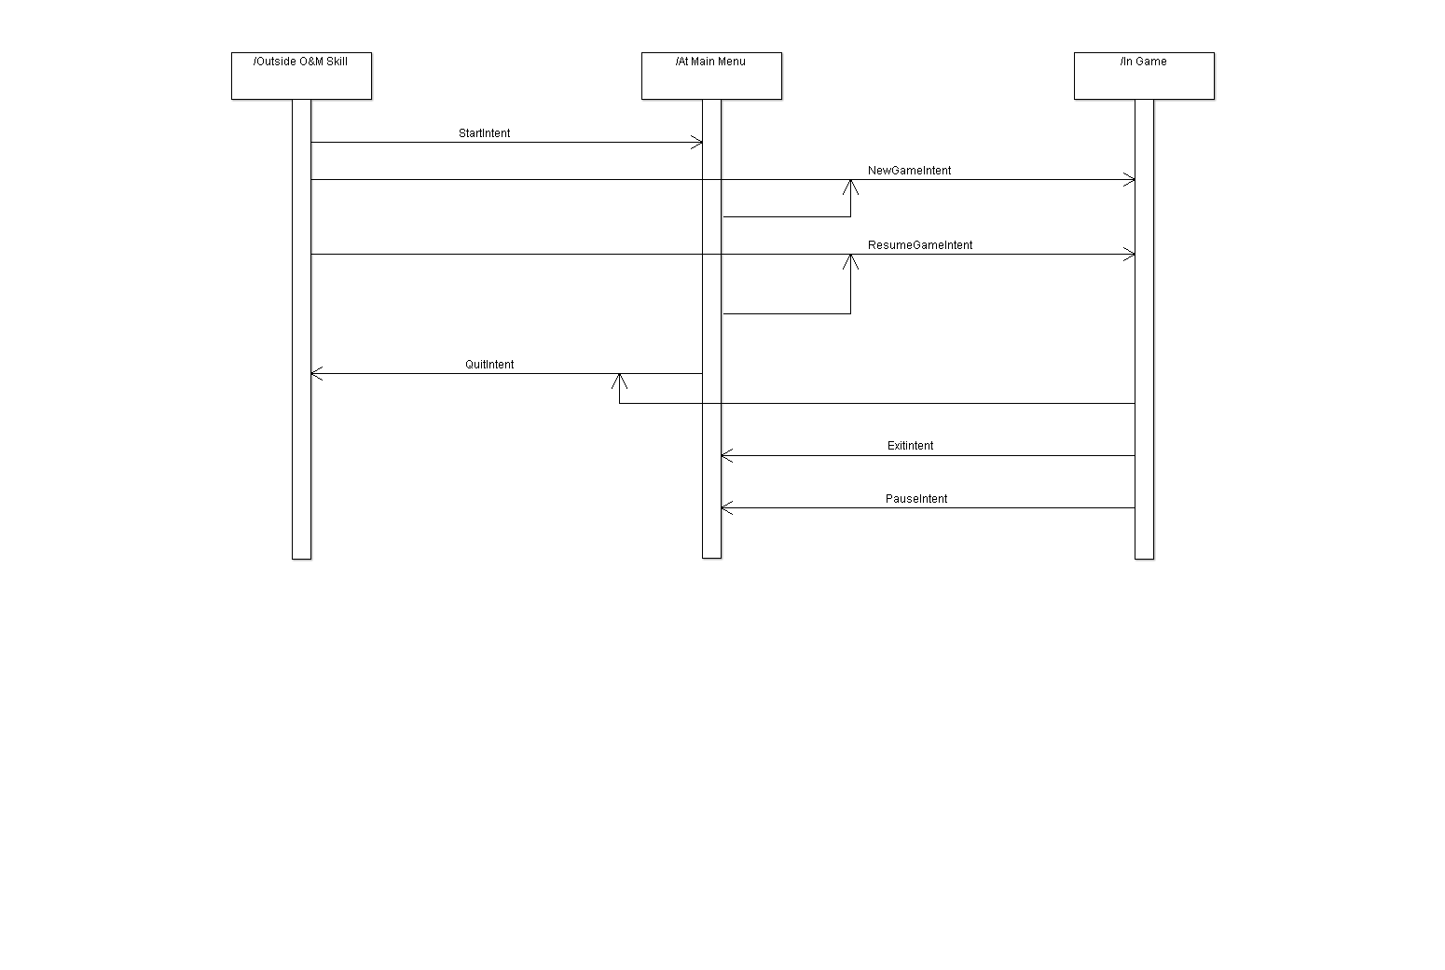For Stage 1 and Stage 2, the only control that will need to be handled will be the utterance-intent-response loop. These actions will navigate between all of the stages. (See diagram for intent actions)

6b. Stage 2: At Main Menu

For Stage 1 and Stage 2, the only control that will need to be handled will be the utterance-intent-response loop. These actions will navigate between all of the stages. (See diagram for intent actions)

6c. Stage 3: In Game

A screenshot of a cell phone

Description generated with high confidenceFor Stage 3, there will be a repeated loop through each question. This loop will terminate either if there is no response after three attempts to garner a response, or if the list of questions has been completed (i.e. the game is finished). See the following UML diagram for the loop actions.

**7. Boundary Conditions**

7a. Start Up

The APH O&M skill will be initiated when a user gives the key words “APH Trivia Game” to an Alexa device. This can be used in any of the different utterances that are provided for start up. The Amazon Alexa service will handle the initial VUI, and when the service finds a request for the O&M skill, it will start the skill

7b. Shut Down

The APH O&M skill will be shut down when a user uses the key word “Quit” to an Alexa device. Using the utterance “Alexa Quit” will automatically shut down the skill, saving the state of the current game. The Amazon Alexa service will handle all of the exit processes to take the user out of the O&M skill.

7c. Errors and Exceptions

The APH O&M skill will handle errors in two ways. The first will assume an error in the VUI. This will cause a repeat of the last phrase that was given to the Alexa device. If this error is caused twice in a row, one more repeat phrase will be given, with examples of the utterances that can be said. At this point, it will be assumed that there is no one playing the game and the game will save state and return to the main menu.

The second error that the skill will handle is an error in the processing of the Hosted Service. These errors will result in the generation of an error report and then the game exiting to the main menu without saving state. We will not save state to ensure a clean, error-free start of the next game.

7d. Data Migration

The APH O&M skill will keep all data stored in cloud storage. The skill Interaction Model will be hosted and stored on Amazon’s Alexa service, with the ability to download the original .xml file at any point for revision or update. The Hosted Service will be available as a JavaScript module on the Amazon Lambda service at any time for update or revision. Using Amazon DynamoDB will allow our database to be cloud based, with tools provided by Amazon that allow for easy import of new data and export of current data.